ATTENTION PARENTS AND CARERS
When on school grounds for drop-offs and collections, please follow social distancing measures at all times to help keep us all safe!
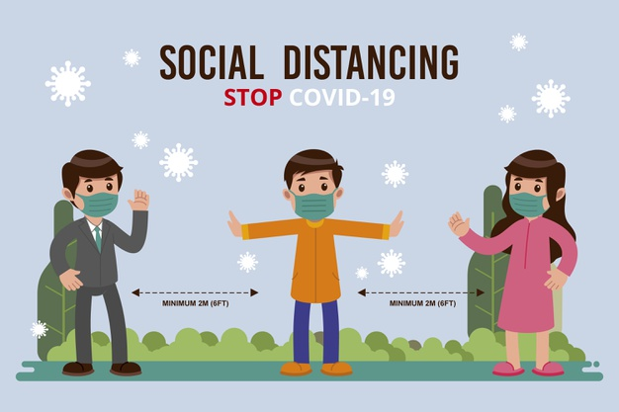

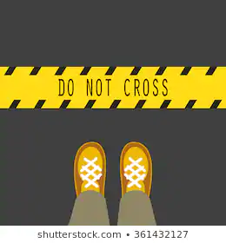
PLEASE STAY 2m APART

PLEASE WAIT BEHIND MARKERS
THANK YOU; STAY SAFE!

