

‘Live to Learn, Learn to Live’

Parental Contract

Quality wrap around care for children at
Lache Primary School
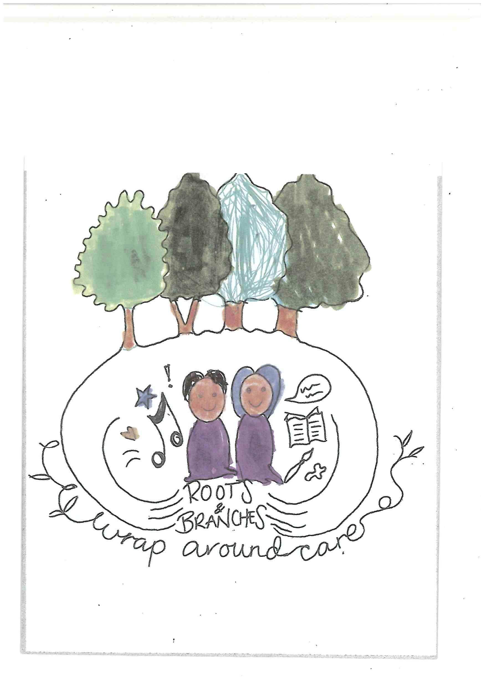

Roots & Branches Club

We provide quality childcare for the children of Lache Primary School for children age 4-11. We can take up to 30 children at any one time and we have experienced and enthusiastic staff. We aim to provide nutritious and filling breakfast/afternoon snacks which will prepare your child for the school day. We are committed to providing equal opportunities for play and participation and we will ensure that your child(ren) have a happy and safe time while at Roots & Branches Club.

Opening Times
We are open every day of the week during term time, from 7.30 – 8.50am (breakfast is served until 8.30am) your child(ren) can be dropped off at any time between these times. Children should enter Roots & Branches Club in the morning via the Front door. Please could all parents / carers ensure that they sign their child in.

The afternoon session runs from 3.15pm until 5.45pm prompt. Children can be collected at any time between these times from the school hall. Please ensure you sign your child(ren) out on collection.

Please note school finishes three time a year at 1.30pm. This is at the end of a full term. On these days we will not provide After School care.

Cost
- Magic Breakfast 8.00-8.50 - £ 2.00 per child/morning
- The morning session - £4
- Full afternoon session - £10 or £2 per 30 mins
- Sibling discounts – 50% discount off 2nd and 3rd sibling. (Except Magic Breakfast)
Payment must be made in advance and cancellation of places requires 4 weeks’ notice, where possible. However, allowances can be made. Payment must be made for reserved places even if your personal circumstances change. Please note that refunds cannot be given and we do not offer credit.

Should an invoice remain unpaid a £10 admin fee will be added to the following months invoice. We reserve the right to refuse further bookings if the full fee is not paid in advance.

Payment should be made via our online system Weduc or with Childcare Vouchers.

Child Information Sheets
Please fill in the attached forms with as much detail as possible. The detail will be held by the Roots & Branches Club staff.

Policies
We have a vast range of policies and procedures which you are welcome to come and have a look at any time during our opening hours.

General
- Please enter and exit the club through the Main entrance.
- We offer a range of activities including a homework area, reading area, craft corner and outside play; weather permitting.
- Healthy breakfast and afternoon snacks will be provided. Breakfast will be a choice of wholemeal toast and low fat spread, fruit, cereal, milk and fruit juice. Our range of afternoon snacks are listed below. This will change and is flexible as the needs and preferences of our children change too!
- All children in Early Years and KS1 will be escorted to and from the club. Children in years 3,4,5 & 6 will make their own way to /from their classroom/club.
- Nursery children will be considered at the discretion of the Headteacher
- We are always open to new ideas and suggestions or thoughts regarding Roots & Branches Club as we do appreciate your feedback.

Contact Details:
Play Worker: Pat Williams

Tel: 01244 470380
Please use the number above during club opening times and the school number at any other time.

Roots & Branches Child Information Sheet

A separate form is to be completed for each child

Child

Full Name:………………………………………………………………………………………………………………...

Name (prefers to be called): …………………………………………………………………………………

Home Address: …………………………………………………………………………………………………………

………………………………………………………………………………………………………………………………………

………………………………………………………………………………………… Post Code:……………………….

Age:……………………………………… Date of Birth: ……………………………………………………..

Parent/Carer

Name:…………………………………………………………………………………………………………………………..

Address: …………………………………………………………………………………………………………………….

………………………………………………………………………………………………………………………………………

Telephone: ……………………………………………….. Mobile: ……………………………………………….

Email: …………………………………………………………………………………………………………………….….

Contact in case of emergency (above will be called first)

1. Name……………………………………………………………………………………………………........................

Address: …………………………………………………………………………………………………………………….

Telephone:…………………………………………………………………………………………………………………..

2. Name……………………………………………………………………………………………………........................

Address: …………………………………………………………………………………………………………………….

Telephone:…………………………………………………………………………………………………………………..

Collection Arrangements:

The child named will be collected by the following adults only:

…………………………………………………………………………………………………………………………………………………..

Care Information

Please give details of any allergies, illness, special needs, dietary restrictions etc

………………………………………………………………………………………………………………………………………………

Doctor

Please give details of doctor and surgery that your child is registered with:

…………………………………………………………………………………………………………………………………………………..

…………………………………………………………………………………………………………………………………………………..

Medication

I will notify the one of the club workers of any specific medication which may need to be administered to my child, and I understand that I will need to complete an additional consent form.

I agree to inform you in advance of any alterations in the above arrangements for collection my child.

Roots and Branches Club Emergency Consent

In an emergency, when a parent’s attendance cannot be immediate, it may be necessary to obtain treatment for a child from a doctor or the casualty department of a hospital. We would ask that you give your consent below in the unlikely event of this occurring.

Signed: (parent/guardian)

Name of Child:

Date of signature:

Roots & Branches Club
Booking Form

Child’s Name:…………………………………………………………………………………………………………………………

Age…………………………………………………………………………………. Class ………………………………………….

The following sessions are required commencing………………………………………………………
Morning Session - 7.30am – 8.50am

Please tick which session and then the days.

Magic breakfast - □ please indicate your days below
Full morning session - □ please indicate your days below

Monday □ Tuesday □ Wednesday □

Thursday □ Friday □

Afternoon Session - £4 per hour/£10 whole session – 3.15 – 5.45pm PROMPT.

Monday □ Tuesday □ Wednesday □

Thursday □ Friday □

Please remember:
The cost does not change depending on the time you arrive or collect. Payment must be made in advance and cancellation must be 4 weeks’ notice. We accept payment through Weduc or childcare vouchers only. We do not offer credit.

We reserve the right to refuse further bookings if the full fee is not paid in advance.

Parent/Carer Name……………………………………………………………………………………………………………….

Signature ……………………………………………………………………………………………………………………………….

Date:………………………………………………………………………………………………………………………………………..

Password
We will be operation a password system when your child is collected from the club. Please ensure that any adult who has permission to collect your child is aware of the password. Please write your chosen password below.

Collection Password …………………………………………………………………………………

