Welcome to Little Explorers

Soon, your child will be starting Nursery. It’s an exciting time! There are lots of things you and your child may wish to know.
Do feel free to come and speak to myself (Lauren Carnell) or my team, we are all very friendly and we know it’s a big step for you and your child.
In the meantime here are some points which may be help to know.
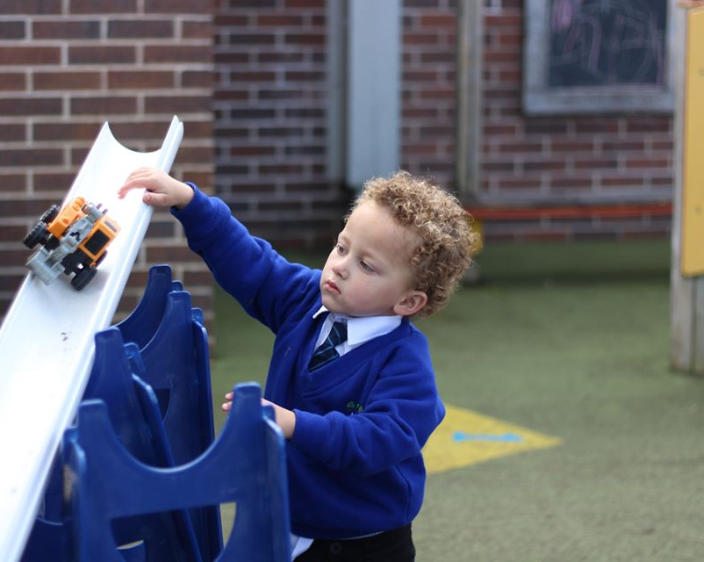
School hours
We start our school day at 8:50am. We will open nursery doors at 8:50 but if you wish to speak to any of us we are around from 8:30.
Lunch time is 12:00 to 01:00. Children can choose to bring a packed lunch or have a school dinner (priced at £2.00 per day)
The end of the school day is 3:00pm; we will see the children out from the classroom.

Follow us
We use Facebook and twitter regularly and try to keep you up to date with all the exciting things we get up to.
Look us up on Facebook – Littleexplorersnurseryatlacheprimaryschool
Twitter – Lacheprimaryschool
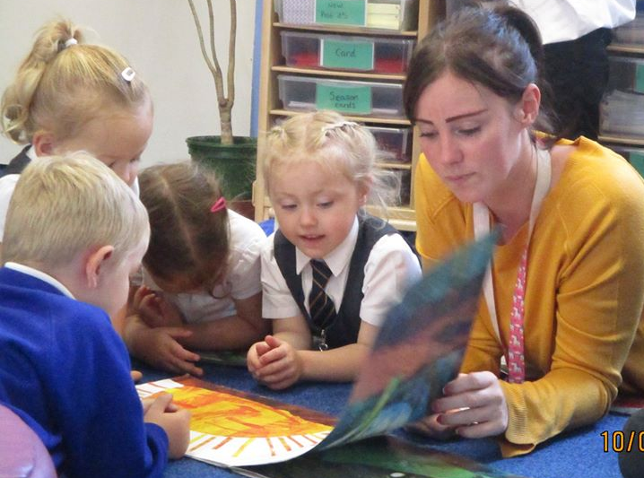

Sickness
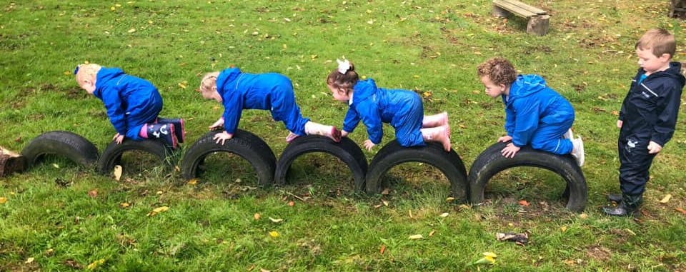
If your child is poorly and can’t come to school please let us know. If your child has had sickness or diarrhoea, please note they will need a minimum on 2 days off school so not to spread the illness.

School uniform
Children are expected to wear school uniform. This consists of sweatshirt/cardigan, grey trousers or skirt, white shirt and tie. Children must also have a pair of wellie boots and a book bag in school at all times. You can purchase school jumpers/cardigans, fleeces, book bags and ties from a shop in Handbridge
Uniformity, 22-26 Handbridge, Chester, CH4 7JE
Tel: 01244 566486
Email: info@uniformityclothing.co.uk
Your child
Please can we ask that all uniform has your child’s name in please.

Spare clothes
As you can imagine in Nursery we like to get messy! Please could each child have a bag with spare trousers, a top, underwear and socks with their name in. Each child will have a cubby to keep their things safe.

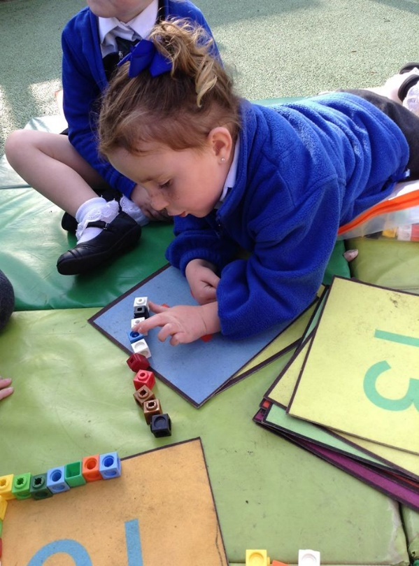
Wellies
It is very important that your child can have outdoor learning experiences throughout the year. We have waterproof suits available but your child will need to have a pair of wellies to keep in school so they can have access to them when they need them. Please can these be named as well.

Medicine
If your child is on any medication, including inhalers and needs it during school hours, can you please bring it in to a member of staff on the first day of school, a form will need to be completed will all the relevant details.

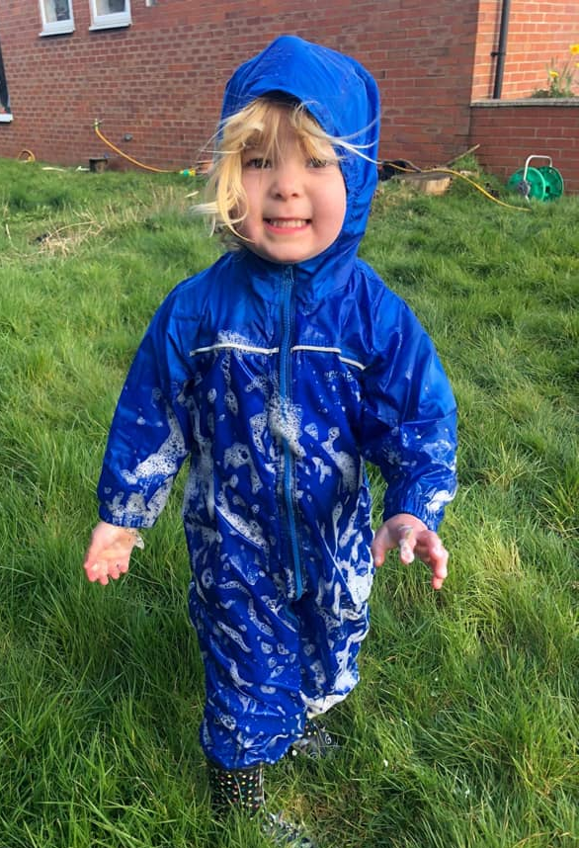
Snack
Snack money is £2.00 each week. Children in nursery help to prepare a variety of snack and this provides lots of different learning opportunities and experiences. Children have free access to water throughout the day and milk is offered to all children at snack times.

Preparation
We ask for every child to bring a family photo with them to school. We put these up in the classroom and we find it helps a lot when children are missing home to have a quick look at their loved ones.

We can’t wait for you to start!

