**Lache Primary School**



**Tel: 01244 981333**

**Website:** [**www.lache.cheshire.sch.uk**](http://www.lache.cheshire.sch.uk)

**Email:**

**admin@lache.cheshire.sch.uk**

**Hawthorn Road**

**Lache**

**Chester**

**Cheshire**

**CH4 8HX**

**‘Live to Learn, Learn to Live’**

**Head teacher: Mrs Kate Seager**

Dear Parents and Carers,

I know you want your child to get the best education and to attend a school with high standards and expectations in appearance, behaviour and learning. That is why I expect children to wear the correct school uniform (including ties), have appropriate hairstyles and to behave, so learning can take place for all.

My staff and I really appreciate your support and want you to know that we will do whatever we can to ensure your child receives a great education, built on high standards.

I will always take time for you when I can, but please appreciate that if you come to see me and don’t have an appointment that I may not be able to see you right away.

Examples of extreme hairstyles that are not appropriate for school…

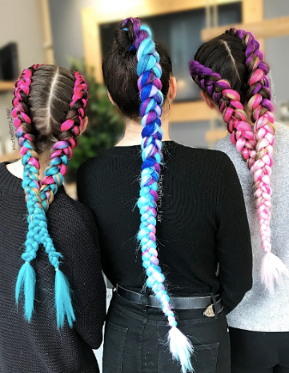 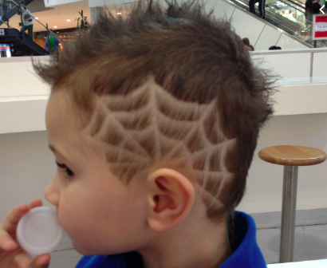 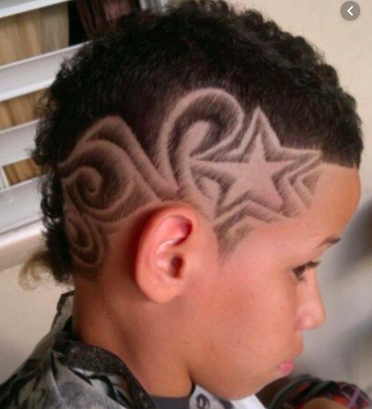

We are a partnership and I know you will continue to support my staff and I to achieve the highest standards for our school and your child.

Yours sincerely,



Kate Seager