Inclusion Matters
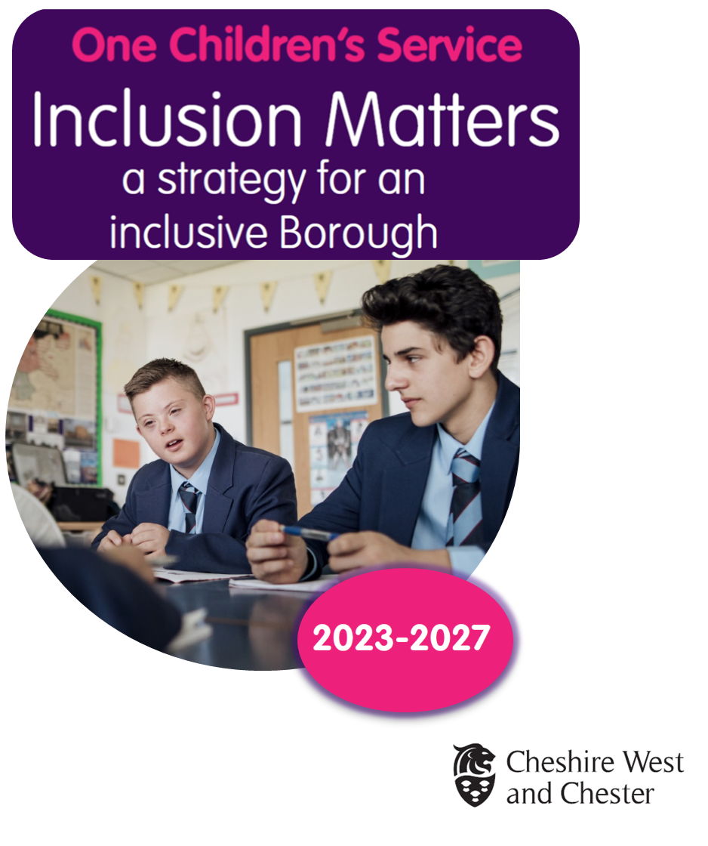

Foreword
As Director of Children and Families I am delighted to present this document. Using information from our current Children and Young People’s Plan, the Joint Strategic Needs Assessment, and what our families, children and young people have said, the strategy represents our vision for the next four years, highlighting areas where we can do more together to benefit the children and young people of Cheshire West, and their families. We want to focus on improving outcomes for children, young people, and their families locally and making this an inclusive borough.
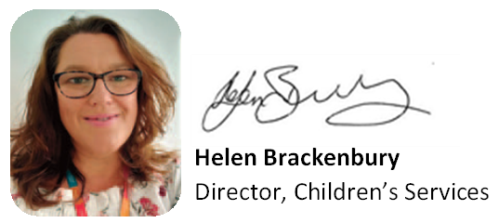

National Context
According to the Department for Education (DfE), Inclusion is education that includes everyone, with non-disabled and disabled young people, including those with special educational needs and disability, learning together in mainstream settings, schools, colleges, and universities. It is also about the quality of all young peoples’ educational experiences, how all children and young people are supported in schools to learn, achieve, and take part fully in the life of schools and settings.
Inclusion is about schools and settings effectively responding to a wide range of needs in the classroom and all teachers having the skills and confidence – and access to specialist advice where necessary – to help all children and young people, including those with Special Education Needs and Disabilities (SEND), to reach their potential and have a positive impact on their lives.
Our Vision for an Inclusive Borough
We want Cheshire West and Chester to be a borough where all children and young people:
- are supported by all to get the best start in life
- are included in education regardless of their need, background, or vulnerability
- find themselves welcomed into ‘good or better’ schools, settings, and post-16 providers across the borough, (as judged by Ofsted).
We want to support schools, settings, and post-16 providers to:
- provide high quality flexible provision
- have a determination to support and encourage all children
- to have child and young person-centred approaches and effective multi-agency working to enable all children and young people to excel, regardless of need
- to have high expectations and aspirations for children and young people, and to be solution focused when meeting needs even in the most demanding of situations
- ensure the voice of parents/carers and children are considered by professionals
- feel enabled through trauma informed lens and effective support services, to meet their statutory duties by using their access and engagement with key services
- use resources effectively and efficiently to identify and meet need whilst acknowledging and respecting the mutual challenges we face with capacity and resources.
It is the Council’s vision that all children and young people should be educated in local mainstream settings alongside their peers, in the borough where appropriate.

Determining the Key Priorities
We have looked at the data that describes our educational outcomes and provision. We have compared ourselves to our previous outcomes, the national picture, the outcomes for the Northwest and for our statistical neighbours. In setting out our priorities we have considered:
- SEND Code of Practice: 0 – 25 Years (2014)
- Removing Barriers to Inclusion (2018)
- Outcome data such as that included in the termly Education Report
- SEND Inspection Outcome 2022
- One Children’s’ Service Peer challenge activities that we undertake across the Northwest
- The SEND High Needs Review 1 and 2
- The SEND Joint Strategic Needs Assessment and the SEN2 Return
- The Annual Conversation with OFSTED
- Surveys such as the Parent/Carer survey
- Relevant Government strategies/policies/reports e.g., New Burdens Guidance: Attendance
- The professional conversations we have with our stakeholders and partners, considering their aspirations and frustrations
- The resolve to sustain and improve across all partners working with children and young people, a sense that we are “one” children’s service
- A multi-agency focus on Emotional Health and Wellbeing of young people
- Right Support, Right Place, Right Time (Green Paper Consultation)
- Trauma informed approaches and development across partners – Our Way of Working
- Averting Exclusions Programme Report

Our Key Priorities for an Inclusive Borough
Inclusion is a shared responsibility of all professionals supporting children, young people and their families in Cheshire West and Chester, this strategy will be monitored regularly by the Council and partners as part of the joint SEND Strategy and Action Plan and Joint Strategic Needs Assessment. Outcomes and progress will be reported to Children and Families DMT and the Children’s Trust.
We believe that all the key priorities for One Children’s Service over the coming years can be captured under the ambition for Cheshire West and Chester to be an inclusive borough.
The priorities we have identified are as follows:

What Matters for an Inclusive Borough?

Inclusion Matter Number 1:
We want every partner to identify children’s individual needs at the earliest opportunity, conduct quality assessment and put appropriate support in place - all in a timely fashion. There should be effective, multi-agency child and young person centred support in place at every transition point. The embedding of Our Way of Working with a Trauma Informed common language will support this.

Inclusion Matter Number 2:
We want every partner, school, and educational setting to welcome all children and families and to work in collaboration with other agencies, families, Transitions Team, health, social care, early years, and Post 16 teams to enable their children and young people to access appropriate and effective full-time curriculum which meets individual need.

Inclusion Matter Number 3:
We want to improve the educational outcomes and aspirations across all Key Stages by focussing on supporting the improvement of outcomes for underperforming, disadvantaged and vulnerable groups of children and young people.

Inclusion Matter Number 4:
We want a confident and skilled workforce across all partners including staff in educational settings so that they can effectively support children and young people’s emotional health and wellbeing. We want the emotional health and wellbeing of adults working with children and young people to impact positively on their engagement and outcomes, so all children and young people are prepared for adulthood.

Inclusion Matter Number 5:
We want a clear strategy and plan of action that ensures that all children and young people are effectively prepared for adulthood.
For each of the priorities we have identified key strands of work that will drive the work of everyone involved in working with children and young people.

Inclusion Matter Number 1:
We want every partner to identify children and young peoples’ individual needs at the earliest opportunity, conduct quality assessments and put appropriate support in place - all in a timely fashion. There should be effective, multi-agency child centred support in place at every transition point. The embedding of Our Way of Working with a Trauma Informed common language will support this.

Key data that informs this priority:
In 2021 – 2022
- 4% of all children and young people in statutory education had an Education Health and Care Plan (EHCP) increase from 3.6% in 2020-2021
- Of the percentage of pupils with an EHC Plan in 2022, 4.6% were under the age of 5 (3.8% national), 34.7% are aged between 5 to 10 years old (32.7% national), 37.2% are aged 11-15 years old (national 35.4%), 20.5% are 16–19 years old (national 20.8%), and 3% are aged 20-25 years old (7.2% national).
- 14.8% of children with a social care referral had a disability recorded
- 9.0% of children on a Team Around the Family (TAF)
- 20.0% of children in the care of the Council have an EHCP
Key Strands of Work:
- We expect all partners, schools, and settings to continue to follow the SEND Code of Practice (2014) and the 0-25 SEND Inclusion Framework
- We expect all partners, schools, settings, and post-16 providers to support the implementation of the actions arising from the High Needs Review 1 and 2
- We will co-produce and promote a Cheshire West and Chester Inclusion Mark
- We expect everyone working with children and young people to embed Trauma Informed practice, Person Centred Planning Practices and support the use of One Page Profiles
- We expect all agencies to align Personal Education Plans (PEPs) and other statutory plans around individual children
- We will look to further increase the confidence and skills of partners, staff in schools and settings to meet the needs of children through workforce development and outreach support
- We will identify, promote, and share good practice to enable the effective transition of children and young people across key stages
- We will co-produce a transition protocol with partners, schools, and settings
- We will support children, young people, and their families to step up or down from professional support via Team Around the Family (TAF), Children in Need (CIN), Child Protection (CP) and Children in Care (CIC) plans at the earliest opportunity, where appropriate, and safe to do so
- We will embed Multi-Agency Group Supervision (MAGS) and Learning Conversations as part of Our Way of Working practice.

Inclusion Matter Number 2:
We want every partner, school, and educational setting to welcome all children and families and to work in collaboration with other agencies, families, Transitions Team, health, social care, early years, and Post 16 teams to enable their children and young people to access appropriate and effective full-time curriculum which meets individual need.

Key data that informs this priority:
In Cheshire West and Chester in 2021 – 2022
- There were 2588 suspensions (primary 277, secondary 2289 and special schools 22), 43 Permanent Exclusions (primary 1, secondary 42)
- There was a 34% increase on previous year requests for an EHCP
- There was a 64.5% increase on previous year of new plans issued
- A higher proportion of children with Education Health and Care Plans (EHCPs) are in special school provision at 40.9% (34.8% national)
- 65.0% of primary school children with an EHCP were educated in mainstream setting
- 39.9% of secondary school children with an EHCP were educated in a mainstream setting
- 89.1% of 2 years old and 93.9% of 3- and 4-year-olds accepted early years provision. 57% of 3- and 4-year-olds accepted the extended 30 hours.
- 272 Multi Agency Group Supervisions/Learning Conversations
- Overall Absence was 4.6%, Persistent Absence was 11.5%, and Severe Absence was 1.2% (2020-2021 due to lag in data)

Key Strands of Work:
- We will look to avert exclusions through effective earlier multi-agency intervention
- We expect partners, schools, and settings to improve the attendance for all groups of children and young people particularly those with Persistent or Severe absence
- We will look to increase the confidence and skills of staff in mainstream schools to meet the needs of all children through workforce development and outreach support
- We will develop an Attendance Strategy in line with the New Burdens guidance
- We will develop an Alternative Provision Strategy in collaboration with partners, schools, and settings
- We will embed the Alternative Provision Guidance to support the monitoring process for young people placed in Alternative Provision
- We will introduce a Part time Timetables policy to support settings in a framework for monitoring reduced timetables for pupils in very exceptional circumstances
- We will collaborate with partners, schools, and settings to implement and embed all new statutory guidance as per the Department for Education expectations.
- We will continue to embed across all schools and settings, Emotionally Based Non School Attendance (EBNSA) Guidance by offering training
- We will continue to embed Mental Health support in all schools
- We will support schools and families to consider all options where families are considering Elective Home Education (EHE) or Education Other Than at School (EOTAS)
- We will support schools and settings to use the Fair Access Protocol (FAP) process to ensure children and young people have continuity of education where appropriate
- We will build on success of the pilot Outreach Programme to support mainstream schools to include children with additional needs

Inclusion Matter Number 3:
We want to improve the educational outcomes and aspirations across all Key Stages by focussing on supporting the improvement of outcomes for underperforming, disadvantaged and vulnerable groups of children and young people.

Key data that informs this priority:
In Cheshire West and Chester in 2021-2022:
the DfE strongly discourage users of the 2022 data from drawing conclusions based on direct comparisons with performance data from previous years and other schools due to the impact of Covid 19 pandemic. The data below are a guideline only
- 67% of children reached a Good Level of Development in Early Years (national 65%).
- Key Stage 2, 58% of children reached the Expected Level in the combined Reading, Writing and Maths measure (national 59%).
- At KS4 the Attainment 8 score for all children was 48 (national 49), and the Progress 8 score was -0.08 (national 0).
- Disadvantage Outcomes
- At EYFS the GLD measure the ‘gap’ between Cheshire West and Chester Non-Disadvantaged and Disadvantaged was 27 percentage points (national 20 percentage points)
- Key Stage 2, combined measure of Reading, Writing and Maths the ‘gap’ between Cheshire West and Chester Non-Disadvantaged and Disadvantaged was 28 percentage points (national 23 percentage points)
- Key Stage 4 the ‘gap’ between Cheshire West and Chester Non-Disadvantaged and Disadvantaged for the Attainment 8 measure was 19 (national 15) and for Progress 8 measure it was 1.03 (national 0.7).
- 3.7% 16–17-year-olds were Not in Education, Employment or Training (NEET).

Key Strands of Work:
- We will review our School Improvement Strategy and the changing OFSTED framework
- We will monitor, support and challenge schools and settings in line with our School Improvement Strategy
- We expect system leaders, especially through the Cheshire West Education Improvement Board, to support and challenge schools across the borough to improve outcomes where there is underperformance without compromising inclusive practices especially for disadvantaged children and young people
- We expect Academy Trusts, Teaching Hub, and other groupings of schools such as local Education Improvement Partnerships to appropriately focus their work and ensure that there is an impact on improving attainment and with any identified attainment gaps closing
- We expect Chairs of Governors, Local Authority governors and Chief Executive Officers (CEOs) of Multi-Academy Trusts (MATs) to ensure that underperformance is challenged by all partners, and robust plans are in place to improve performance and close attainment ‘gaps’
- We expect all schools, settings, and post-16 providers to be Attachment Friendly, Trauma Informed and set ambitious targets for all Children in Care, Previously Looked After and Children in Need, and all disadvantaged or vulnerable groups
- We will capture and promote good practice for transition across all key stages to support progression and continuity, and co-produce transition guidance informed by local and national research.

Inclusion Matter Number 4:
We want a confident and skilled workforce across all partners including staff in educational settings so that they can effectively support children and young peoples’ emotional health and wellbeing. We want the emotional health and wellbeing of adults working with children and young people to impact positively on their engagement and outcomes, so all children are prepared for adulthood.

Key data that informs this priority:
In Cheshire West and Chester in 2021-2022
- Overall, 4.0% of pupils in CW&C had an EHCP and 11.6% had SEN support
- At primary schools, 2.2% had an EHCP (2.3% national), and 12.2% had SEN Support (13.0% national)
- At secondary schools, 1.8% had an EHCP (2.2% national), and 9.9% had SEN support (11.9% national)
- At special schools, 99.8% had an EHCP (98.7% national
Key Strands of Work:
- We expect every school, setting, post-16 provider and every partner agency to embed Inclusive Practice, Trauma Informed Practice, Our Way of Working strategies and use appropriate language
- We will sustain, increase, and improve the range of evidence-based practice to impact on the emotional health and wellbeing of children and young people. We will seek to build the capacity of partners, schools, settings, post-16 providers and wider children’s services to identify the early signs of mental health difficulties and intervene or signpost appropriately
- All children and young people will have access to mental health first aid
- We expect every school, setting, post-16 provider and partner agency to have a plan to promote the Emotional Health and Wellbeing of all adults to subsequently support Emotional Health and Wellbeing of children and young people
- We will provide training in local evidence based Emotionally Based Non School Attendance (EBNSA) Guidance to support targeted children and young people
- The Virtual School will promote and support training and accreditation for trauma leads in schools
- Early Help and Prevention (EHP) Service will continue to promote early identification of individual family needs and collaborate with appropriate teams
- We will continue to support all agencies to embed trauma informed practice through Our Way of Working (OWOW)
- We will monitor progress of this strategy and linked action plans through The Children’s Trust Emotional Health and Wellbeing (EHWB) subgroup
- We will ensure commissioned services will provide targeted support to children, young people, and their families
- We will support Mental Health Support in Schools Team to provide targeted support to children and young people
- We will continue to embed a One Children’s Service approach to supporting families
- We will continue to offer and evaluate ELSA training and supervision to Teaching Assistants in our schools so that they can devise interventions to support children and young people’s emotional literacy skills
- We will continue to promote Mental Health First Aid Training (MHFAT) for schools.

Inclusion Matter Number 5:
We want a clear strategy and plan of action that ensures that all children are effectively prepared for adulthood.

Key data that informs this priority:
In Cheshire West and Chester in 2021-2022
- 3.7% of 16–17-year-olds (universal) were Not in Education Employment or Training (NEET)
- 8.3% of 16–17-year-olds with an EHCP, were Not in Education Employment or Training (NEET)
- 8.7% of 16-17-year-olds with SEN Support were Not in Education Employment or Training (NEET)
- 92.8% of 16–17-year-olds were in Education Employment and Training (EET).
Key Strands of Work:
- We expect partners and schools to promote increased aspiration and introduce the world of work from the primary phase onwards
- We expect schools, colleges, and other providers to continue to collaborate with the Council to increase and improve the range and quality of provision post-16 and post-19 for children and young people who experience disadvantage, vulnerability or SEND and address gaps where necessary
- We will continue to collaborate with parents and carers to increase their confidence in the range of pathways available from childhood to adulthood
- We will collaborate with schools and providers to increase Supported Internship and Journey First opportunities, so we increase the numbers of disadvantaged, vulnerable young people, including those with SEND, entering employment
- We will increase the number of Post 16 young people including care leavers engaging in Education Employment and Training and increase the number of Employment Opportunities offered to young people through the Supported Apprenticeships and Supported Internships within the borough.
- We expect schools and colleges to provide high quality independent careers information, advice, and guidance
- We will support Travel Training for Post 16 young people where it is appropriate to support them access Education, Employment or Training
- We will implement any recommendations from the Transitions Review in a timely manner.

Enablers to Achieve an Inclusive Borough

There are a number of enablers that will support the above ambitions:
- Effective working relationships and shared aspiration across partners, schools, settings, post-16 providers
- Continuing to embed our approach to co-production
- Continuing to embed Our Way of Working across all partners using shared language and Trauma Informed approaches
- Ensuring that commissioned services across all partners are aligned with the Council’s ambitions for an Inclusive Borough
- Ensuring that all partners align appropriate financial resources, to support the Council’s ambition for an Inclusive Borough across all partners and take every opportunity to seek external funding to support this programme
- Using national and local evidence-based practice and research to inform all our work
- Collaborate with all partners to drive this programme forward on behalf of all stakeholders
- Special Educational Needs Co-ordinator (SENCo) clusters to support the delivery of Inclusive Practices in all schools and educational settings
- Implementation of Orchestra – Software links data from the school’s management information system to local authority data management systems
- Developing ICT systems to provide consistency and accurately recording of reliable data
- Developing technology to inform trends and identify areas of strength and challenge
- Local Area multi-agency SEND Strategy and Action Plan
- Our Local Offer website
- Our Starting Well commission
- Occupational Therapy (OT) commission
- Our Speech and Language Therapy (SALT) commission
- Entitlement of 2 years plus funding for Early Years places

Groups/policies from all areas of the Council that support Inclusion
- Local Area SEND Strategy and Action Plan
- Local Offer
- Early Help Strategy
- Preparation for Adulthood Strategy
- E-TAF website
- Safeguarding Children’s Partnership
- Parent Carer Forum - Annual Survey
- SEND JSNA
- Council Plan
- Children’s Plan
- Children’s Trust
- Our Way of Working
- Alternative Provision Guide
- Reduced Timetable Policy

Partners we have consulted in drafting this Strategy
All Schools (including Academies)
Parent Carer Forum
Children in Care Council
Childrens Social Care
Early Help and Prevention Team

