Lache Primary
School

Live to learn, learn to live

- Behaviour Management Policy Trauma informed, Attachment aware and
- Anti-Bullying Policy

Approved by Governors – Autumn 2023-2024

'Live to Learn, Learn to Live’
At Lache Primary, pupils are supported and nurtured to help develop their aspirations for their future as learners and as positive contributors to society. We expect every pupil to put learning first, work hard and be nice to themselves and others to achieve the highest academic standards.
We offer a safe and enjoyable learning environment where excellence is promoted.

Aims and Objectives
Our key purpose is to ensure the wellbeing and success of all our pupils. The aim of this policy is to ensure that staff, pupils and parents are clear about the behaviour expectations that we have for our pupils and how we will support those pupils who struggle with these in a calm and safe environment.

Our Learning community
To ensure success for all, we have in place a range of interventions to support pupils, develop positive relationships and refocus on learning. At Lache Primary school, we encourage pupils to make good learning and good behaviour choices throughout the school day and make it clear that poor choices (including actions that are a result of ACEs) have consequences for learning and achievement. High expectations of staff and pupils make positive contributions to learning across the school relentless routines will be applied in classes and throughout school to make expectations clear to learners.

Rules and Values
Our School Rules:
- Be Respectful
- Be Ready
- Be Safe

Foundation values
Respect

Positivity

Honesty

Pride

Ambition

Persevera
nce

Core values

These are the rules and values that we expect children, parents, staff and governors to follow and demonstrate always.

At Lache Primary School we firmly believe that the key to our pupil’s happiness and success is by being ‘Trauma Informed’ and ‘Attachment Aware’. We have undertaken much training on the subject and are continuing to embed this way of working and ethos within the school to ensure that our children have the very best life chances ahead of them.
We follow a number of key principles…

- Being ‘fair’ is not about everyone getting the same (equality) but about everyone getting what they need (equity).
- Behaviour is a form of communication.
The change in terminology in the 2014 Code of Practice of Special Educational
Needs (SEN) - which replaces the Behaviour and Social Difficulties (BESD) with
Social, Emotional, and Mental Health (SEMH) difficulties – helps to promote a shift towards viewing behaviour as a communication of an emotional need (whether conscious or unconscious), and responding accordingly (See appendices - comic strip)
- Taking a non-judgmental, curious and empathic attitude towards behaviour. We encourage all our staff in to respond in a way that focuses on the feelings and emotions that might drive certain behaviour, rather than the behaviour itself. Pupils with behavioural difficulties need to be regarded as vulnerable rather than troublesome. At Lache Primary School we all have a duty to explore this vulnerability and provide appropriate support.
“Thinking of a child as behaving badly disposes you to think of punishment. Thinking of a child as struggling to handle something difficult encourages you to help them through their distress”
(from Colebourne Primary School’s Behaviour Policy)
- Putting relationships first.
At Lache Primary School we pride ourselves on developing and promoting a school ethos that promotes strong relationships between staff, pupils and their parents/carers. We aim to create a positive school culture and climate that fosters connection, inclusion, respect and value for all members of our school community.
- Maintaining clear boundaries and expectations around behaviour. Changing how we respond to behaviour does not mean having no expectations, routines or structure. In order to help our pupils feel safe, their educational environment needs to be high in both nurture and structure. Our pupils need predictable routines, expectations and responses to behaviour. We have endeavoured to put these in place and model appropriately, within the context of a safe and caring school environment. Natural rewards and consequences that can follow certain behaviours are explicit and laid out within this policy. More often than not we encourage the children to decide on an appropriate consequence together with staff. This is done without shaming or ostracising our pupils from their peers, school community and family, leading to potentially more negative behaviour.
- Not all behaviours are a matter of ‘choice’ and not all factors linked to the behaviour of are within their control. Therefore, the language of choice (e.g. ‘good choice/bad choice’) is not always helpful. As a staff we try to avoid using this language to describe behaviour.
- Behaviour must always been viewed systemically and within the context of important relationships (i.e. a relational communication pattern rather than an internal problem).
- Encouraging parental engagement and involvement is absolutely crucial when addressing and planning support for our pupil’s SEMH needs.
“The parent-child connection is the most powerful mental health
intervention known to mankind”

At Lache Primary School we use a mixture of emotional coaching strategies and restorative practices to support our pupils (see restorative practice in appendices)

Step 1: Recognising, empathising, soothing to calm (‘I understand how you feel, you’re not alone’)
Step 2: Validating the feelings and labelling (‘This is what is happening, this is what you’re feeling’)
Step 3 (if needed): Setting limits on behaviour (‘We can’t always get we want’)
Step 4: Problem-solving with the child/young person (‘We can sort this out’, ‘How else could we have dealt with this situation?’)

Absolute Consistencies
There are five consistencies that all staff will uphold in the school.
All adults at Lache Primary school will:
- Model positive behaviours.
- Allow colleagues engaging with children, time and space to do so and only intervene if requested to do so.
- Actively greet all learners as they enter the learning area.
- Will calmly and slowly deal with disruptive learners by ensuring they are ‘stepped through’, giving ‘take up time’, every time
- Follow up every time personally and engage in reflective dialogue with pupils

Lache Primary School’s Behaviour Policy is underpinned by effective inclusion of the pupil in daily high-quality teaching i.e. differentiated activities that meets the needs of all individuals. It is essential the behaviour is addressed in the moment by the adult witnessing the school rules not being met.

Rewards and Acknowledgements
In lessons, teachers will reward good behaviour, excellent work in books and hard work with Dojo points and Scooby spends. All adults including HLTAs, TAs and MDSAs can also reward the children for showing the school values and following the rules with Dojo points.
When a child has excelled in a lesson they may be sent to show their work to a member of SLT – who will reward them with stickers and Dojo’s.
Celebration assembly will celebrate a ‘Star of the Week’ from each class who receives a certificate detailing how they have impressed the adults in their class that week. Children will also be given a sticker and parents will be invited to attend the Celebration Assembly that week to celebrate with their child. Acts of kindness and attendance is also celebrated at this assembly. Freddo Friday is a regular and awards to those pupils who have stood out in class for positive reasons.

All staff are to make at least one phone call home a week praising a child for their positives choices. SLT will also send out weekly postcards for children nominated by their class teacher.

Dojo Points
Children will receive Dojo awards for good work, positive behaviours, upholding the school values and following the school rules.
Children will build up their dojo account and then be able to ‘cash them in’ for prizes, once they reach 100.

Consequences
Consequences at Lache Primary School have a learning focus, build relationships and encourage pupils to take responsibility. Restorative approaches are encouraged and supported. All pupils must be given ‘take up time’ in between steps. If the children are not following the school rules they are:
- Reminded – Children are reminded of the expectations, repeating as necessary, deescalating and redirecting to keep things at this stage
- Cautioned – a clear verbal caution is given and delivered privately, where possible, making the learner aware of their behaviour and the consequences if their behaviour continues (See scripts)
- Given a last chance – Learners are spoken to discretely, positive choices are offered, and reminders of previous good behaviour are given.
- Given time out - This may be in the room or in another room with work (TA to escort). A short restorative and emotional coaching conversation (See scripts) should take place afterwards.
It is not possible to leap steps or accelerate steps for repeated low-level disruption. Secondary behaviours will generally be tactically ignored at the time they are displayed but will be discussed with the pupil when they are once again calm and rational.

Pupils who repeatedly display low level inappropriate behaviour during the week should be notified via Cpoms to Deputy Head teacher or equivalent senior leader by the classroom teacher on a Friday or sooner if necessary.

School events, school trips and school clubs
The school reserves the right to withdraw the offer of a place on a trip, club or event should a pupil's behaviour give cause for concern over their ability to participate in a responsible and acceptable manner. The school also reserves the right to withdraw the offer of a place on a trip, club or event if there are concerns in regard to health and safety due to a pupil’s behaviour.

Fixed Term and Permanent Exclusions
We will endeavour to avoid exclusion from the school wherever possible. A decision to exclude a pupil for a fixed period is taken only in response to very serious breaches of the school’s rules or where the behaviour of the child means that it is not safe for them or for staff for them to remain in the school at that time. The head teacher, or the most senior member of staff in their absence, will take the decision to exclude a pupil and will also decide upon the length of the exclusion and whether it is to be fixed term or permanent. External exclusion should be avoided at all costs. Internal exclusions should only be used where necessary and the pupil should not be in total isolation but with a senior member of staff. The time should be spent have restorative and reflective discussions with the pupil reintegration meetings will take place with both parents and the pupil upon their return.

Parental Involvement
Parents will be involved at the earliest possible stage following on from normal school procedures and particularly if problems are persistent or recurring. Children may then be placed on a daily or weekly report system (best cards) to monitor their behaviour with parents’ support. Where children are placed on the ‘Vulnerable Pupil Register’ parents, carers and social workers may need to be informed about behaviours and consequences. Staff will record these issues on CPOMS (Behaviour).

Dealing with Significant Challenging Behaviour
Any significantly challenging behaviour needs to be handled carefully and with compassion. Children who behave aggressively, refuse, use inappropriate language or act in ways which are disruptive to the learning of other children, usually have pressures in their lives which cause these behaviours. As staff we need to be understanding of these, but still need to deal with
‘unacceptable behaviour’ appropriately and consistently.
Every effort should be made to contain these types of behaviours by using class consequences and these should be consistent, giving children reasonable amounts of ‘take up’ time. Should behaviours persist or escalate to a level which cannot be tolerated, the following procedures should be employed.
- Initially, support should be sought from another member of staff. The additional member of staff should support with dealing with behaviours rather than take over. Often it is best for a supporting member of staff not to say anything directly to the child initially.
- If there is no improvement in the behaviours, the child should be removed from the situation using verbal commands/requests only.
- If this is not possible, it may be necessary to physically remove a child from the situation. In order for this to take place, at least one member of ‘Team Teach’ trained staff should called for (it is always preferable to have 2 trained members wherever possible). A list of all staff with ‘Team Teach’ training is available in the staff room, in the school office and held in Class Files.
- The ‘Team Teach’ trained member of staff will assume authority for the removal of the child. • In most cases, pupils can be ‘guided’ away from a situation to a safe place. However, when this is not possible it may be necessary for staff to resort to the use of ‘Team Teach’ restraint techniques.
- Any ‘Team Teach’ restraint must be recorded in the appropriate Bound and Numbered book. (Bound and Numbered book are held in The Willows and the Headteacher’s Office)
- Support from staff from The Willows may be sought and it may be appropriate for children to be escorted to The Willows for short periods of time in order to have a ‘safe place’ to calm down.

Use of restraint techniques.
Only staff trained in ‘Team Teach’ techniques should carry out restraint unless:
- There is an immediate threat to the child’s personal safety
- There is an immediate threat to the safety of another person
- There is an immediate threat to property which could then cause a danger to the child or others (i.e. the breaking of glass, electrical items, etc)
In the very rare instance that a child in mainstream may become extremely aggressive towards an adult, they should where possible be escorted to The Willows which will provide a safe environment for both adults and pupils.
If the child continues to be unable to conform to the agreed behaviour patterns the SEND procedures will be followed as appropriate:
  - Pastoral Support Programmes
  - Advice from other agencies (possibly a TAF)
  - Modified Curriculum
  - Support from Learning Mentor
  - Utilising the Resource Provision within the school
  - Modified School day
Further Action
The school will consider:
  - partial or full time support within the Resource Provision (in consultation with the local authority)
  - lunchtime exclusion • a fixed-period exclusion • permanent exclusion.

Children Leaving School Premises
Should a child leave school premises by any means, adults should in the first instance alert the school office and then if possible observe the child from the school grounds. If the child remains stationary outside of school and it is possible to engage with the child then attempts should be made to encourage the child to return to school. If the child moves away from school, adults should not, under any circumstances, follow the child but should remain on school property. The police and parent/carer should be called to report the child as absconded. Risk reduction plans should be revised as necessary and a full report detailing the events prior to child absconding should be completed and forwarded to the Head teacher.
If it is considered that there is a high risk of repeat behaviour it may be necessary to consider exclusion on the grounds of managing the child’s future safety.

Part B - Anti Bullying Policy (including cyberbullying, prejudice based bullying and discriminatory bullying. This includes homophobic, racist and gender related incidents)

Aims
At Lache PrimarySchool we recognise the negative impact that bullying can have on a child’s life. As a result, we do all we can to prevent it, by developing a whole school ethos in which bullying is regarded as unacceptable.
We aim, as a school, to produce a safe and secure environment where all can learn without anxiety, and proactive measures are in place to reduce the likelihood of bullying.
This part of the policy aims to produce a consistent school response to any bullying incidents that may occur. We strive to make all those connected with the school aware of our opposition to all types of bullying, and we make clear each person's responsibilities with regard to the eradication of bullying in our school.

Definition - What is bullying?
There are a great many definitions of what constitutes bullying and bullying behaviour. Most definitions consider it as being repeated words or actions, which are aimed at causing another to feel frightened, miserable or helpless. All bullying and bullying behaviour has the following in common:
- it is deliberately hurtful;
- it is repeated, often over a period of time;
- it is difficult for the target of the bully or bullying behaviours to defend themselves against the negative behaviour
- seriously damages a young person’s confidence and sense of self worth
- can lead to prolonged emotional damage

Bullying or bullying behaviour can be categorised into the following areas, however, there is no hierarchy of bullying – all forms of bullying should be taken equally seriously and dealt with appropriately.

Physical: assault, pushing, shouldering, elbowing, tripping, slapping, kicking, hair pulling, unacceptable touching (including that of a sexual nature), throwing missiles, blocking i.e. preventing movement through an access point, pinching, stabbing, burning, spitting or any other form of physical activity that makes another person feel threatened or intimidated.
Verbal: racist, sexual, homophobic, biphobic, transphobic words used in a derogatory manner, any words used in a sexual or aggressive manner designed to hurt or cause deliberate offence, comments about size, appearance, odour, clothing, academic or other abilities, home life, social circumstances, financial circumstances, spreading rumours or any bothersome outcomes designed to be hurtful or used to intimidate.
Written: any insults contained in note-passing, threatening letters, graffiti, defacing any property belonging to another individual.
Interference with another individual: Theft, extortion, vandalism, defacing of property, ruling games, blackmail or any other activity designed to intimidate or hurt.
Psychological pressure – silent bullying: Social exclusion, rude gestures, lying, slander, passing or starting rumours, name calling, reorganising or pressurising friendship groups or any other activity designed to intimidate or hurt an individual.
Racist bullying: name calling, incitement, making comments about a person’s country or culture or appearance or commenting on parents or spreading rumours.
Homophobic, biphobic and transphobic bullying HBT: name calling, making hurtful comments, using LGBTQ+ vocabulary in a negative way (e.g. – using gay to express something as inferior), commenting or slandering parents or other relations/friends including spreading rumours.
Subtle bullying: Giving looks intended to intimidate, belittle or discredit someone, swearing at or about a person.
Incitement of others to become involved e.g. by bribery, blackmailing, excluding, or threatening behaviours.
Cyber bullying: Emailing or texting about a person or to a person, spreading rumours or defacing or corrupting a piece of work. Instant messaging or posting on a social network platform such as WhatsApp or SnapChat and using any language identified above. This is also applicable to online chat rooms.

The role of Governors
The Governing Body supports the Headteacher in all attempts to eliminate bullying from our school. The Governing Body will not condone any bullying at all in our school, and any incidents of bullying that do occur will be taken very seriously, and dealt with appropriately.
The Governors require the Headteacher to keep accurate records of all incidents of bullying, and to report to the Governors on request about the effectiveness of school anti-bullying strategies.
A parent who is dissatisfied with the way the school has dealt with a bullying incident can ask the Chair of Governors to look into the matter. The Governing Body responds within 15 days to any request from a parent to investigate incidents of bullying. In all cases, the Governing Body notifies the Headteacher, and asks her to conduct an investigation into the case, and to report back to a representative of the Governing Body. [see Complaints Policy]

Responsibility
It is the responsibility of all staff to ensure the implementation of the school antibullying strategies, and to ensure that all staff (both teaching and non-teaching) are aware of the school policy, and know how to identify and deal with incidents of bullying. The Headteacher reports to the Governing Body about the effectiveness of the antibullying policy on request.
The Headteacher and Senior Leadership team ensures that all children know that bullying is wrong, and that it is unacceptable behaviour in our school. The Headteacher draws the attention of children to this fact at suitable moments. For example, if an incident occurs, the Headteacher or senior leaders of the school may decide to use an assembly as the forum in which to discuss with other children why this behaviour was wrong, and why a pupil has to have appropriate consequences. Areas such as language surrounding racism and HBT are discussed during PSHE, whole school assemblies and work on British Values to ensure pupils have a clear understanding of what language is acceptable and unacceptable.
The Headteacher ensures that all staff, receive sufficient training to be equipped to identify and deal with all incidents of bullying. The Headteacher sets the school climate of mutual support and praise for success, supporting children’s self-esteem to reduce the likelihood of bullying incidents. When children feel they are a valued member of a friendly and welcoming school community, bullying is far less likely to be part of their behaviour.

The role of the teacher and support staff
All the staff in our school take all forms of bullying seriously, and seek to prevent it from taking place. - listen to the child
- ensure a record of the incident is made and added to the central behaviour report forms ( in appendix) and on ‘CPOMS’
- inform the Headteacher
- speak to the alleged perpetrator
- speak to the victims and perpetrator’s parent
- actively set up a system to try and prevent future incidents. E.g. inform the learning mentors so that some 1-1 work can be completed with the child.
- ensure that the school rewards and sanctions are followed consistently and that the school behaviour policy is followed.
- If teachers witness an act of bullying, they will either investigate it themselves or refer it to the Headteacher.
Teachers and support staff do all they can to support the child who is being bullied.
This may involve:
- counselling and support for the victim, and carrying out the appropriate consequence for the offender.
- Time is spent talking to the child who has carried out the bullying, explaining to them why their action was wrong and how they should change their behaviour in future.
- Once a resolution/understanding is reached review must be held regularly to ensure that the bullying has ceased.
If a child is being bullied over a period of time, then, after consultation with the Headteacher or Learning Mentor a meeting will be arranged with the child's parents.
The Headteacher/SLT records all incidents of bullying which occur both within school, near school and on the journeys to and from school.
In more extreme cases, e.g. where these initial discussions have proved ineffective, the Headteacher may contact external support agencies, such as the Social Services or the Behaviour Support Team.

Anti-bullying within the curriculum
We are a ‘No Outsiders’ school and seek to promote diversity, equality and inclusion.
Our school uses a range of methods to help prevent bullying and to establish a climate of trust and respect for all. We use drama, role-play, stories etc., within the formal curriculum, to help pupils understand the feelings of bullied children, develop empathy and practise the restraint required to avoid lapsing into bullying behaviour. Pupils are taught that they have rights and one is to feel safe in school. Pupils are taught to stand up not only for their own rights, but also to respect the rights of others.
Circle time/class discussion is used to praise, reward, and celebrate the success of all children, and thus to help create a positive atmosphere as well as to teach mediation and problem solving skills. Areas such as language surrounding health, racism and HBT are discussed during PSHE and work on British Values (acceptance, mutual respect etc) to ensure pupils have a clear understanding of what language is acceptable and unacceptable.
In addition, children learn about online safety and cyber-bullying within their computing lessons and through specific trips and visitors throughout the year. Related concerns and strategies are further explored when the school participates in annual Internet Safety Week activities. Children learn how to stay safe and what to do if they experience cyber-bullying.
Every year, school recognises Anti-Bullying week and uses this time to focus heavily on how to prevent bullying.
We strive to ensure that the contributions of all pupils are valued and everyone feels secure and able to contribute to school life. We challenge stereotypical views and value differences in others whether arising from race, culture, gender, gender identity, sexuality, ability or disability.

The role of Parents/Carers
Parents are asked to actively support our schools anti-bullying policy, behaviour policy and sign the home school agreement which all promote good behaviour. Parents should feel confident that our school does not tolerate bullying and deals with any incidents swiftly and seriously. If they suspect that their child may be the perpetrator or the victim of bullying they should contact their child's class teacher immediately.
If they are not satisfied with the response, they should contact the Headteacher.
Parents are encouraged to support safe use of digital technologies- selecting and monitoring age-appropriate social media and messaging apps. This is supported with the distribution and regular updates of what is new to look out for and how to keep their child safe online.

The role of Pupils
Pupils are encouraged to tell someone they trust if they are being bullied, and if the bullying continues, they must keep on reporting it. Pupils are invited to tell us their views about a range of school issues, including bullying, in a number of ways. This could be by speaking to an adult, a school council rep or through worry boxes or individual class systems.

Monitoring, reporting and review
This policy is monitored by the Headteacher, Senior Leadership Team and Governors.
This policy will be reviewed annually.
Appendix 1 – Consequences -(lunchtime thinking room - TR)
Willows manage their own behaviour in house
Best cards to be used for those children who need support in making the right choices ion a regular basis
LM to work with individuals or small groups to support
Nature of Incident | School rule broken | Consequence
Deliberate physical assault of adult | Be Respectful  Be Safe | - Dealing with Significant Challenging Behaviour form completed and attached to CPOMs entry  - Internal/external exclusion
Deliberate physical assault of pupil (unprovoked serious harm) | Be Respectful  Be Safe | - Dealing with Significant Challenging Behaviour form completed and attached to CPOMs entry  - Internal/external exclusion  - Post exclusion daily visits to SLT member
Harm caused following provocation | Be Respectful  Be Safe | - Restorative meeting  - Loss of playtime/privilege TR
Swearing /abusive language towards an adult/child  verbal assault | Be Respectful | - ‘If heard by adult’ (not heresay)  - Restorative meeting – possible loss of playtime/privilege up to internal / external exclusion (dependent) TR  - Post incident daily visits to SLT member
Not following the E-safety rules | Be Safe | • IPad/computer ban - length in discussion with ICT co-ordinator
Fighting | Be Safe  Be Respectful | - Restorative meeting with both parties  - Parental involvement  - Could include loss of playtime/privilege, internal or external  exclusion depending on circumstances TR  - Refer to senior member of staff - daily visits to HT/DHT
Rudeness to an Adult  (without swearing) | Be Respectful | • Restorative meeting – potential loss of playtime/privilege TR
Inappropriate behaviour towards another pupil/deliberate provocation | Be Respectful | - Restorative meeting with both parties  – parents informed  - Log and share  - Refer to senior member of staff for repeat or continued behaviours  - Possible post incident daily visits to SLT member
Refusing to follow instructions | Be Ready  Be Respectful | • Restorative meeting with both parties – parents informed TR
Disruptive behaviour that interrupts learning | Be Ready  Be Respectful | - Loss of 5 minutes playtime.  - Referral via CPOMs to Deputy HT if behaviour is repeated throughout week TR
Swearing in the presence of an adult | Be Respectful | - Restorative meeting  - Loss of playtime (or part of) TR

Appendix 2
Scripts (Taken from When adults change everything changes – seismic shifts in school behaviour by Paul Dix)
Remind:
“Our school rules are ………………………….”
Caution:
“I noticed you are….”
“I need to see you….”
“I expect….. “
Given a last chance:
“You need to understand that every choice has consequences. You have chosen to…. If you now choose to do the right thing that would be fantastic. If you choose to…. then this will happen…... Do you remember last week when you…? That is who I need to see today. I will leave you to make your decision”

Appendix 3
Restorative meeting questions:
- What happened, what did you do?
It is important to listen carefully and dispassionately to the child’s account without interrupting or disagreeing. It is equally as important to give your account from your perspective without judgement.
- What were you thinking at the time?
This reflection helps the pupil to reconsider their actions and replay their thought processes.
- ‘What have you thought since?
Many doors are opened through this question that might allow the pupil a change of attitude, a shift in explanation or even the possibility of an apology.
- How did this make people feel?
The child might have been unaware of how other people reacted to their behaviour. The link with the next question is clear. We want to make sure that the child has the opportunity to consider others. To think about the impact of their behaviour on classmates who were worried by their anger, visitors who were shocked or younger children who were scared.
- Who has been affected?
Often the first response to ’Who has been affected?’ is simply ‘Me, I got sent out, I am missing my break. It is only with some gentle encouragement that the child can see the bigger picture; you are teaching them to use their conscience. At the end of this section of the meeting ask the learner to list the people who have been impacted before considering the next question, perhaps remarking,
‘That’s quite a lot of people who have been affected, isn’t it?’
- How have they been affected?
The 5-year-old who pushes in at the front of the dinner queue without any regard for the 29 children who are patiently waiting in line is taught that their behaviour can have an impact on others. Teachers in the early years of schooling spend a great deal of time showing children how their behaviour affects others. They are deliberately encouraging the child to have empathy with other people.
- What should we do to put things right?
For many adults this is the moment to sit back and wait for an apology to be offered. In many restorative meetings this question can up the ante. Run badly the meeting can seem like a build up to it, so it is important that an apology is not demanded. There may be other ways to put things right. Even if an apology is the obvious ‘correct’ step from the adult’s perspective, resist the urge to guide the conversation that way. Every parent knows that a forced apology is worthless. It might take the child time to reach this point.
- How can we do things differently in the future?
A little bit of forward thinking and/or visualisation is not a bad thing. It is likely that the child will meet similar situations and frustrations in the coming days. Some prior planning will help them to recognise when

Behaviour Reporting Form
In the event of an incident of challenging behaviour, the following form should be completed electronically, detailing what has occurred and any further actions taken.
Please complete this form as clearly as possible and save it in the Behaviour Incidents folder on Staff Share.
Incident of unacceptable / challenging behaviour
Name of pupil: |  | Year group:
Location of incident: |  | Date of incident:
Names of other pupils involved:
What happened? (Bullet point)
•
Were any injuries sustained? (If yes, please specify.)

Was physical intervention necessary? (If yes, give details) Yes
No

Please tick and date when the Bound and Numbered book has been completed.
Has the pupil been involved in previous behavioural incidents? (If yes, give details or explain where information can be found)

What action will or has been taken?

How can this incident be avoided in future? (E.g. by providing support for the pupil through utilising counselling services.)

Name and role of who recorded the incident: |  | Date recorded:
Did the incident lead to an exclusion? |  |  |  | Yes |  |  |  | No
If the incident described above led to an exclusion, the form below must be completed along with the Exclusion Letter to Parent/Carer and The school’s Exclusion Monitoring and Evaluation form.
Exclusion
Grounds for exclusion (please tick the relevant box):
 Posed a risk to other pupils or members of staff
 Breach of the law
 Persistent and severe bullying
 Verbal and physical abuse
 Constant disruption
 A single, serious and major incident
Are there any factors which may have contributed to the incident?
Have the pupil’s parents/carers been notified of the exclusion?
Has an appeal been lodged? If so, give details of the case and the decision reached:
Length of exclusion (maximum of 45 school days if not permanent):
Has the governing body been informed of the exclusion?
Headteacher’s signature:

If a pupil has been permanently excluded, and an independent panel has not been requested, please complete the form below.
Taking a pupil ‘off-roll’
Has the pupil been
Y / N
taken off-roll?
Code used whilst pupil’s name remains on the admissions register:
 Code B (Off-site education)
 Code D (Dual registration)
 Code E (No alternative provision arrangements)
Have the pupil’s details been sent to another school?
Contact details of where the pupil’s information has been sent:
Has a common transfer file been uploaded to the DfE?

- a period of time;
Comic strip - Therapeutic Services and Trauma Team
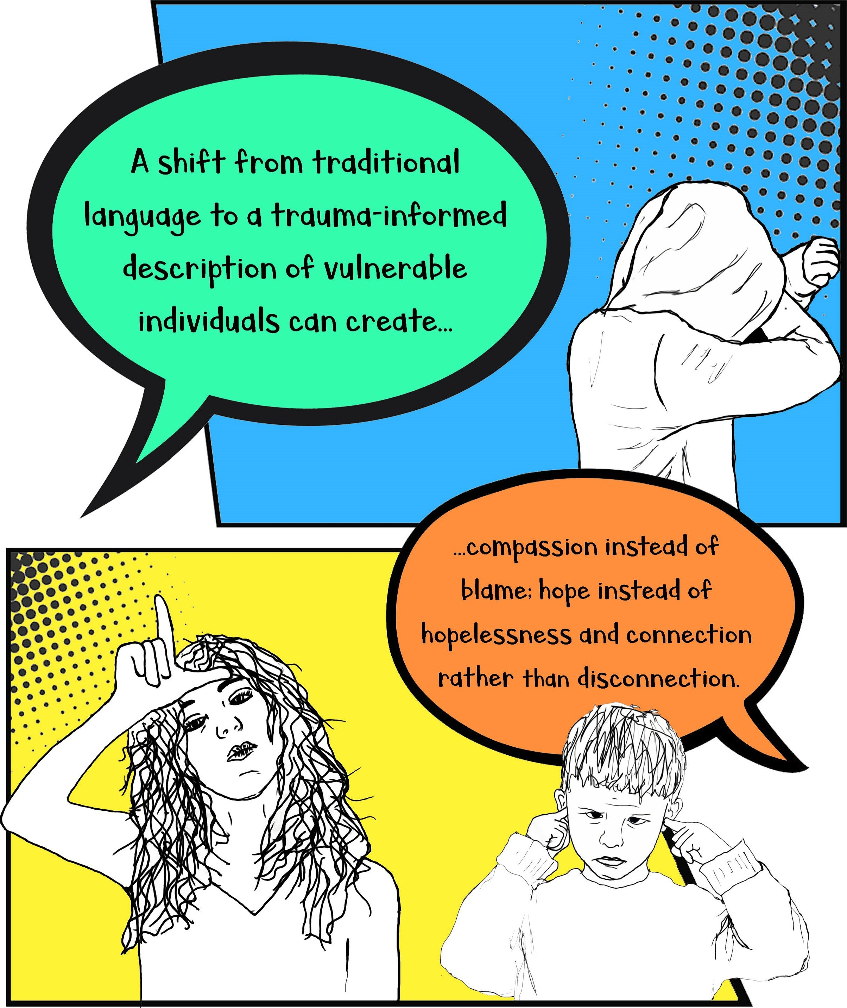
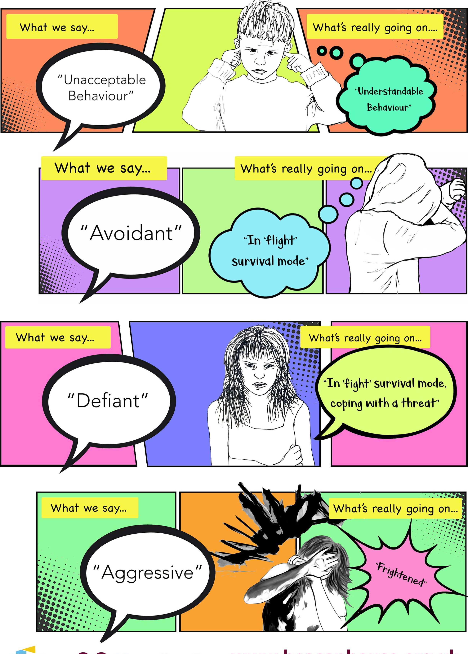
oBeacon Therapeutic Services and HouseTrauma Team O O @BeaconHouseTeam www.beaconhouse.org.uk
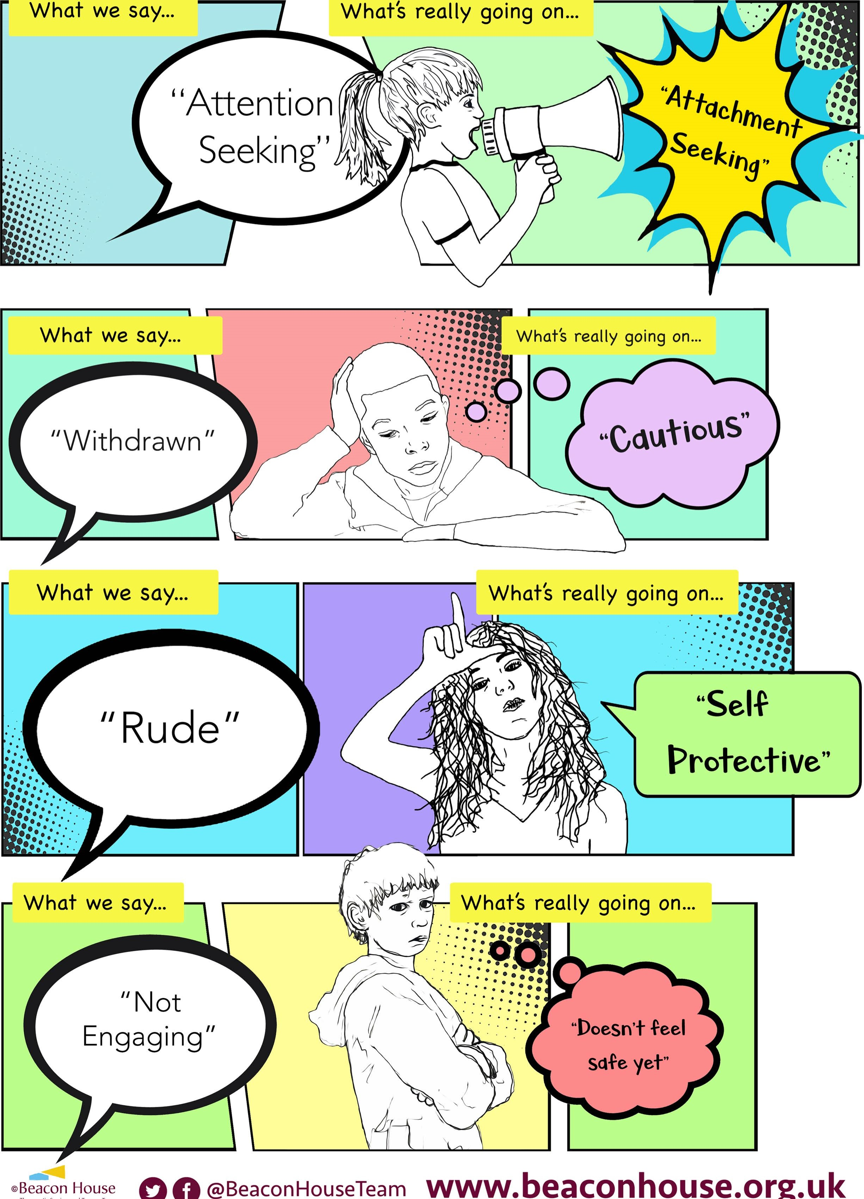
oBeacon House
00
www.beaconhouse.org.uk
Therapeutic
Services
and
Trauma
Team

